**What is Bootstrap?**

A bootstrap is:

* Front-end library

Front End:

* A front end is what the user sees is the beautiful mermaid it’s face of your web.

Back End:

* The backend tends to reside on the server and is basically behind the scenes sort of business logic of how your website or how your app is going to work. So this way you code a lot of functionality of the website or app.

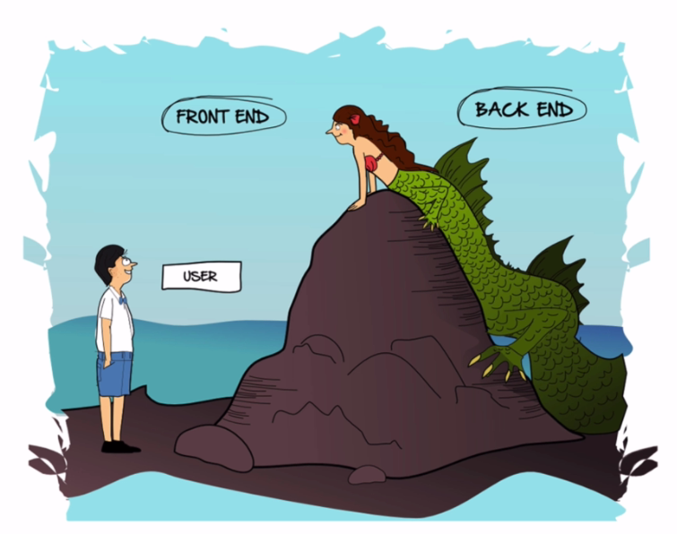

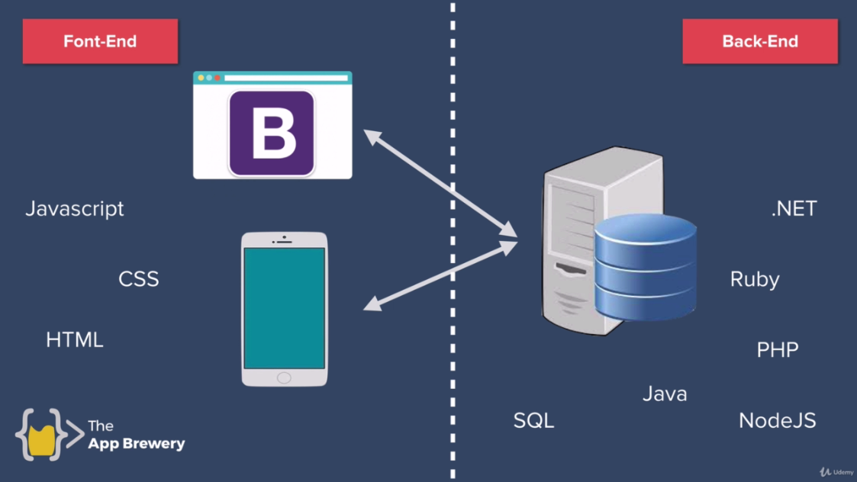

Link:

<https://getbootstrap.com/>

Explore elements in documentation like **jumbotron**

<https://getbootstrap.com/docs/5.2/migration/#jumbotron>

and

<https://getbootstrap.com/docs/4.0/components/jumbotron/>

<div class="jumbotron">

<h1 class="display-4">Hello, world!</h1>

<p class="lead">This is a simple hero unit, a simple jumbotron-style component for calling extra attention to featured content or information.</p>

<hr class="my-4">

<p>It uses utility classes for typography and spacing to space content out within the larger container.</p>

<p class="lead">

<a class="btn btn-primary btn-lg" href="#" role="button">Learn more</a>

</p>

</div>

Examples:

<https://getbootstrap.com/docs/4.0/examples/>

like <https://getbootstrap.com/docs/4.0/examples/product/>